**Tic Tac Toe**

**Introduction**

This project was the final project for Computer Programming II (CS 232). The language we used for this course was Java. Using what we had learnt in class, we were placed into groups of two in order to complete a game of tic tac toe. This project was created using NetBeans, which is a Java-based IDE (integrated development environment).

**Instructions**

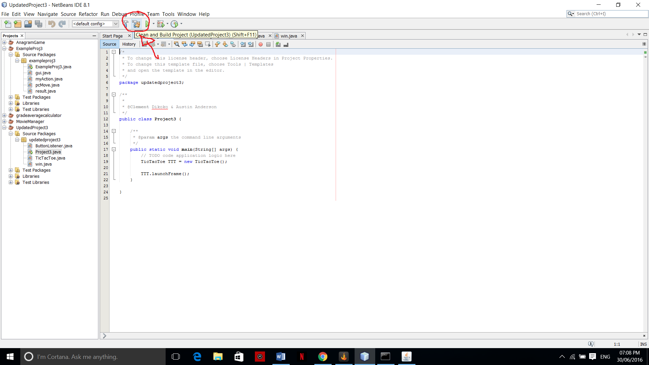Due to the fact that the project was created in NetBeans, it makes it much easier to run the code. There’s a built-in operation that runs the program from within NetBeans. Below is the procedure I used to run the program. First, the project needs to be compiled in the command prompt. To do so, I had to clean and build my project through NetBeans.

Once this is done, NetBeans creates a directory where the file is located and then returns a line that can be pasted into the command line to run the program.

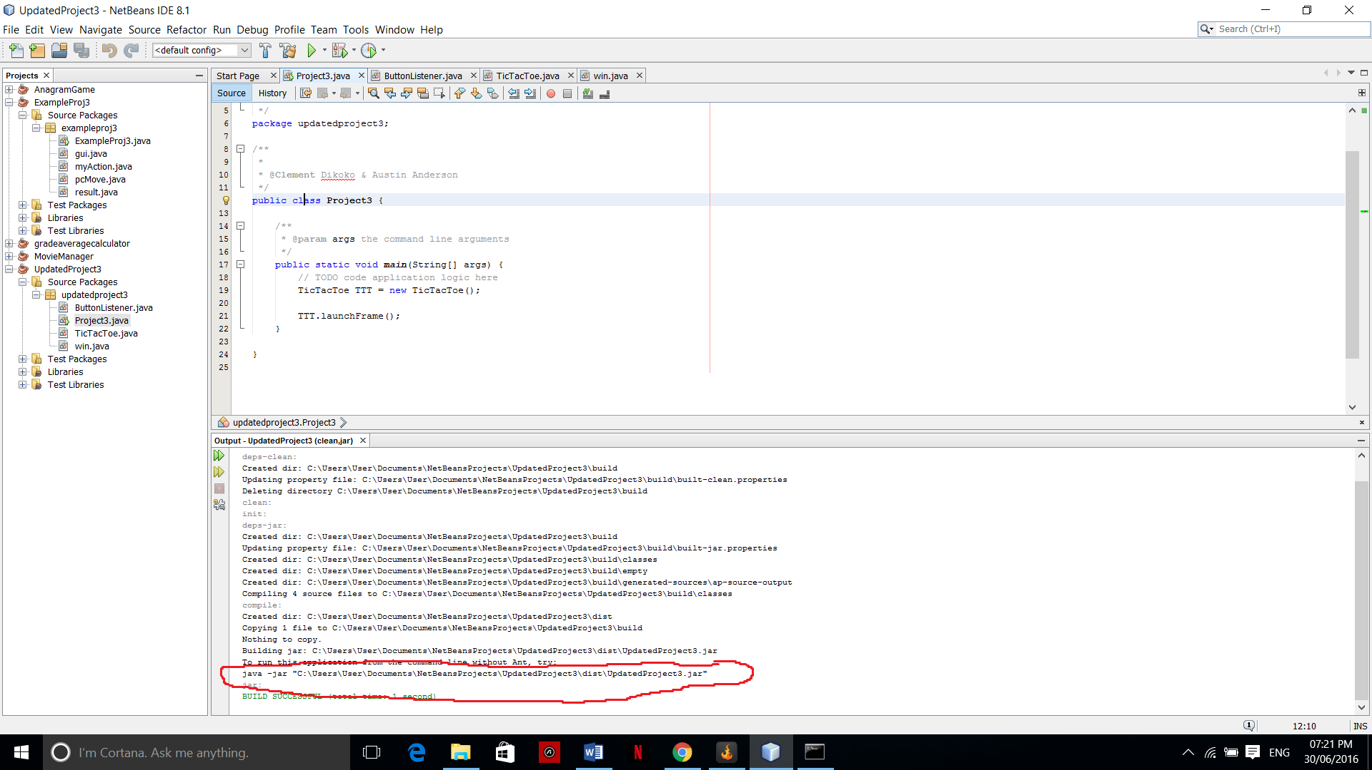

* Copy the final line in the picture above
* 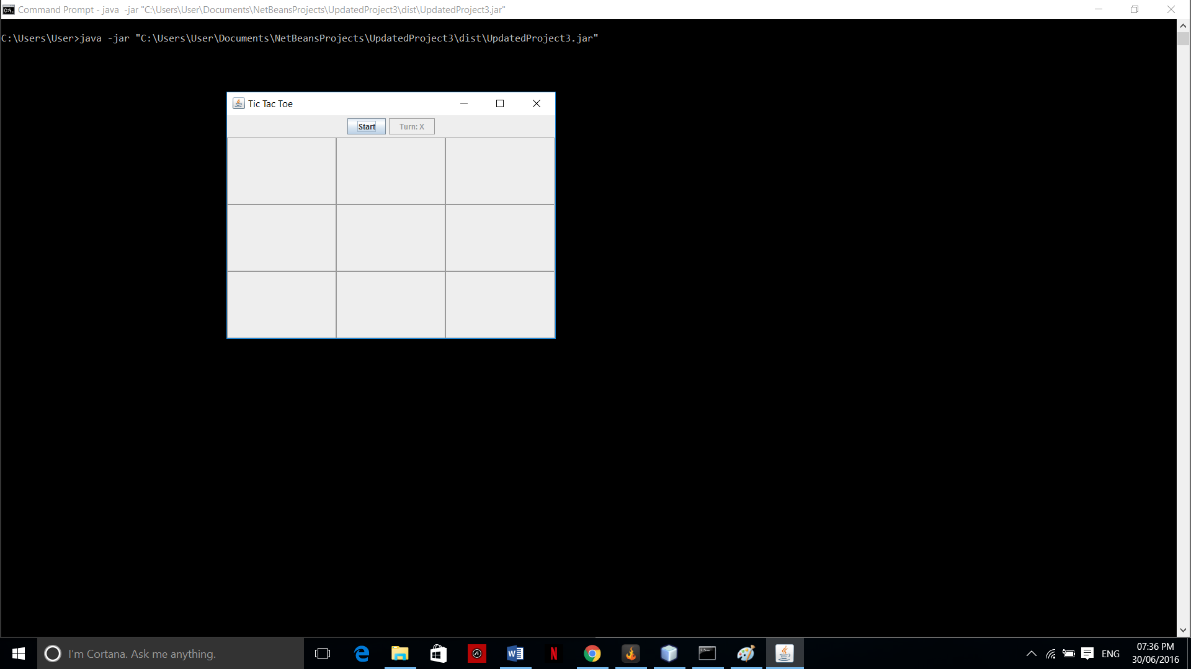Paste it into the command line and the program will run

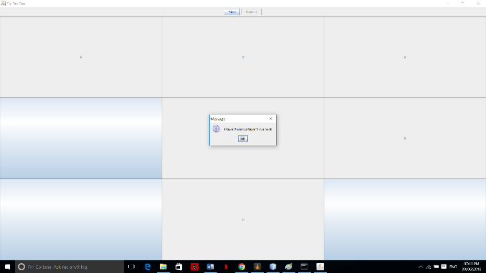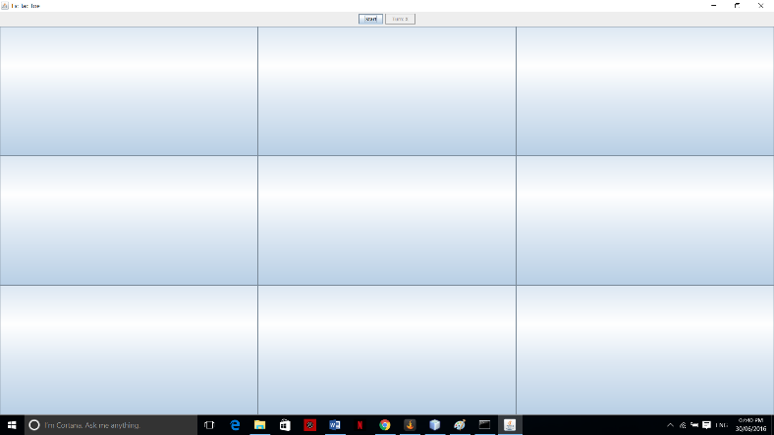The game can hold only two players; the players must alternate once their turn is over. When the user clicks on “Start”, the game begins. Once a winner has been decided, a message appears to state whether player 1 or player 2 has won the match.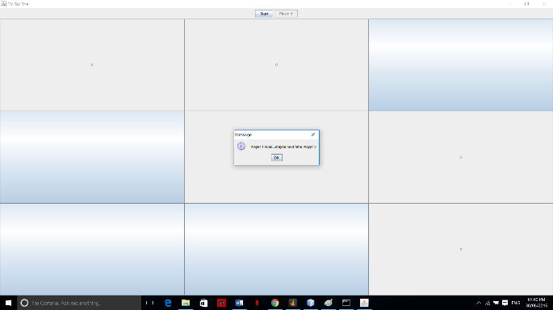

**Notes**

**\***The “X” and the “O” are quite small which is something I would change now, but didn’t have the time to change when we created the program. There are some stylistic features that could have been made differently, but this was only meant to be a prototype of the full functioning game.

Since the project was created using NetBeans, it was a bit difficult finding a way to run the project on the command line. In class we only ran our larger programs through NetBeans, so there was a lack of experience with using the command line to compile and run a project that contained many classes. We researched quite a bit until we resolved the issue, but it was tedious and stressful until we realized how simple the solution was.

This project was the first experience we had working with GUIs (graphical user interface), which made the TicTacToe and ButtonListener class difficult. The TicTacToe contains the information to create the game that the user sees; the ButtonListener class is what allows the user to manipulate the game and displays who’s turn is next. The Win class declares the winner of the game and displays whether or not it was a tie. Finally, the Project3 class is where the main is located, and this is the class that launches the game.

This project required the ability to use and manipulate a JFrame

The biggest difficulty in this project was continuing the work that was already done by my partner. Researching how to create a window with 9 boxes, that we can then use to create a tic tac toe game, is one thing. Reading and understanding my partners code is much more difficult than writing the code myself. That is where I struggled the most in this project; understanding my partners mind and the intentions behind his logic.